|  |  |  |  |
| --- | --- | --- | --- |
| TEST NUMBER | TEST | EXPECTED OUTCOME | ACTUAL OUTCOME |
| 1 | Enter nothing | Tells the user to enter one of the options given. | Same as expected |
| 2 | Enter only numbers | Tells the user to enter one of the options given. | Same as expected |
| 3 | Enter only punctuation | Tells the user to enter one of the options given. | Same as expected |
| 4 | Enter “a” | Takes the user to read file function where they’re asked to enter the file name. | Same as expected |
| 5 | Enter “A” | Takes the user to read file function where they’re asked to enter the file name. | Same as expected |
| 6 | In the Read File function, enter nothing | Tells the user to enter something not nothing then loops them back to the input. | Same as expected |
| 7 | In the Read File function, enter only numbers | Tells the user what they entered is pointless and loops them back to the input. | Same as expected |
| 8 | In the Read File function, enter only punctuation | Tells the user what they entered is pointless and loops them back to the input. | Same as expected |
| 9 | In the Read File function, enter a file name that doesn’t exist | Tells the user the file doesn’t exist locally, then loops them back to the input. | Same as expected |
| 10 | In the Read File function, enter an actual file name | Reads the file and constructs the sentence using the words from the file, outputs it to the user then sends them back to the menu. | Same as expected |
| 11 | In the Compress File function, enter nothing | Tells the user to enter something not nothing then loops them back to the input. | Same as expected |
| 12 | In the Compress File function, enter only numbers | Tells the user what they entered is pointless and loops them back to the input. | Same as expected |
| 13 | In the Compress File function, enter only punctuation | Tells the user what they entered is pointless and loops them back to the input. | Same as expected |
| 14 | In the Compress File function, enter a valid sentence | Tells the user to input the name of the sentence. | Same as expected |
| 15 | In the Compress File function, after entering a valid sentence enter a valid name of sentence | Creates two files containing indexes and words of the sentence, named after the sentence name then takes the user back to the menu. | Same as expected |
| - | Test results for sentence name input are exactly the same as the sentence input | - | - |
| https://i.gyazo.com/57e0a7ac419ac55e65e5584804b5c384.png16 | Enter “C” | Says goodbye to the user then ends the program. | In idle the exit function doesn’t work, but when run standalone the program quits. So kind of what I expected. |

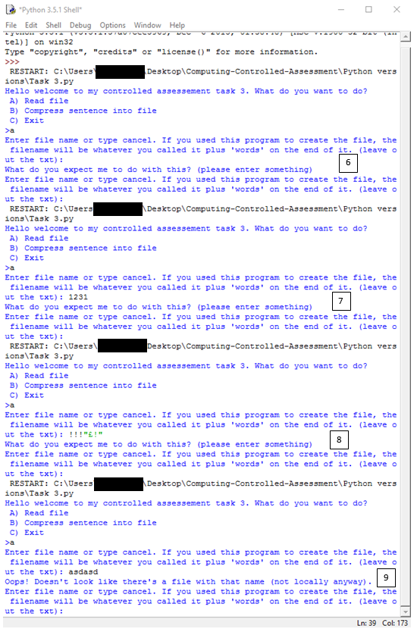

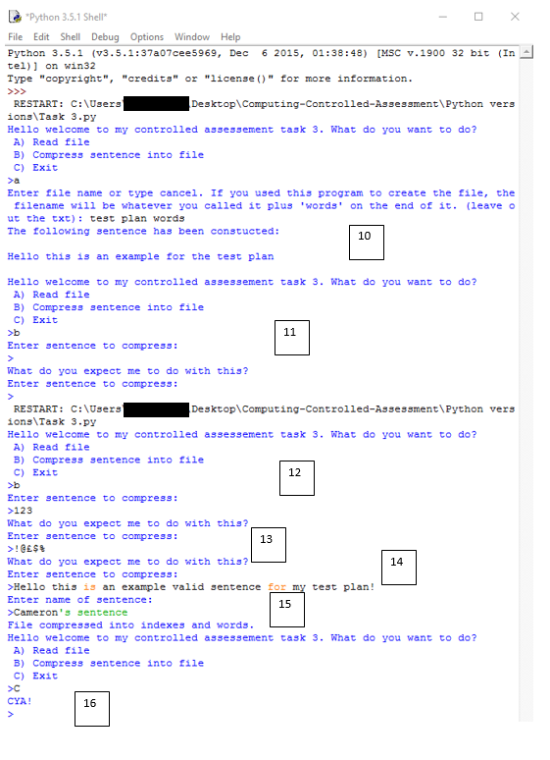

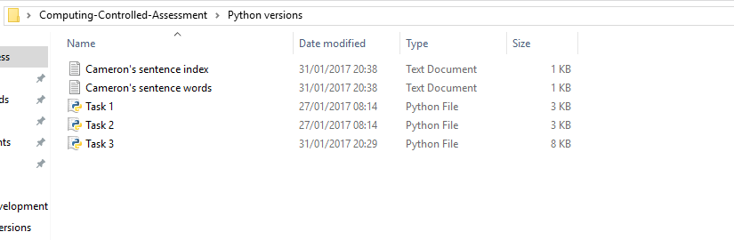

15

